1.Maximum XOR of Two-Overlapping Subtrees

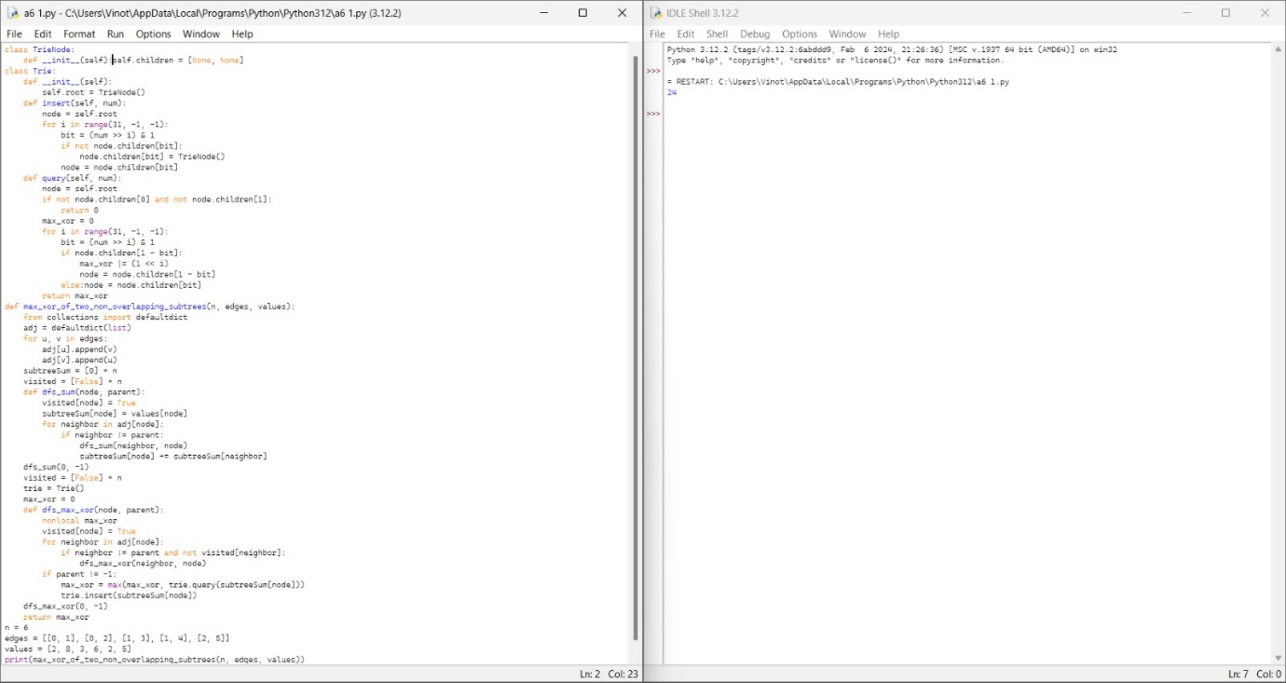

2.Form a Chemical Bond

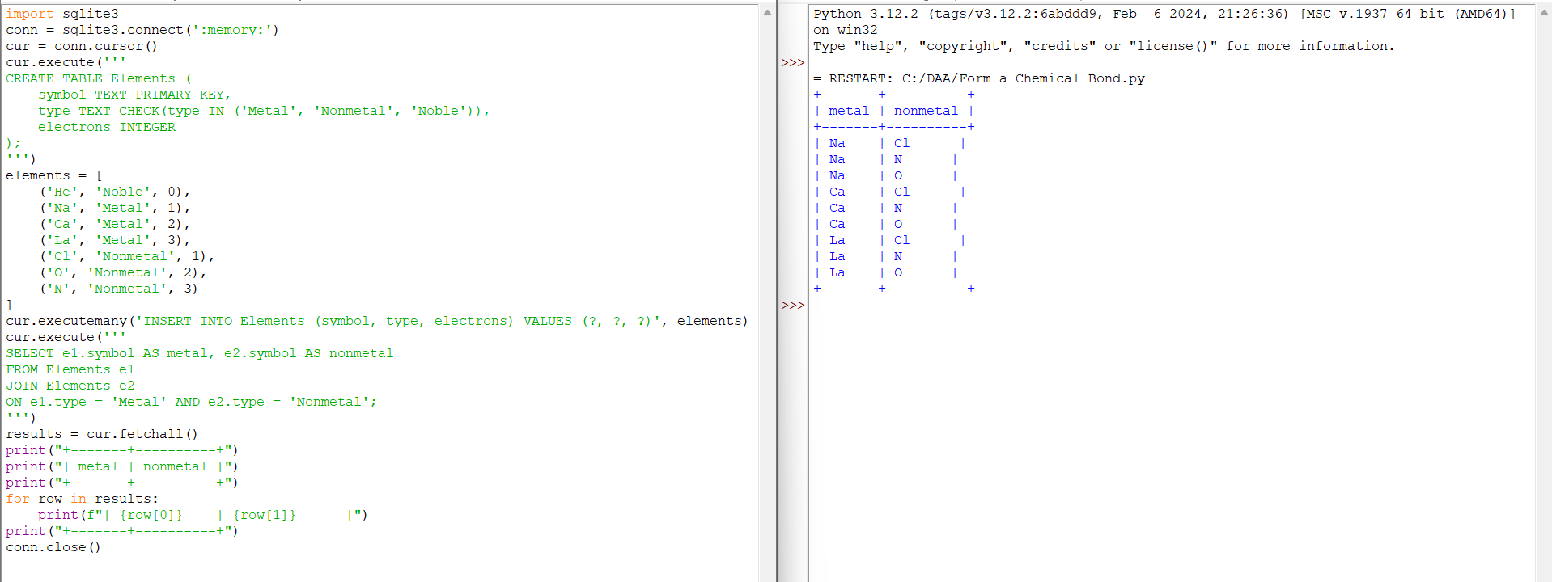

3.Minimum Cuts to Divide a circle



4.Difference Between Ones and Zeros in Row and Column

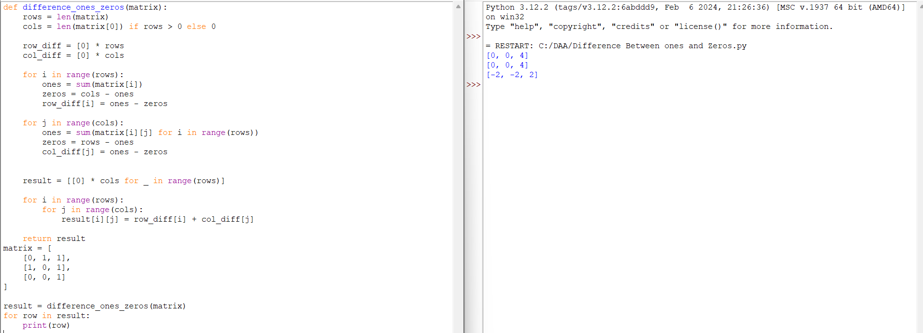

5.Minimum Penalty for a shop

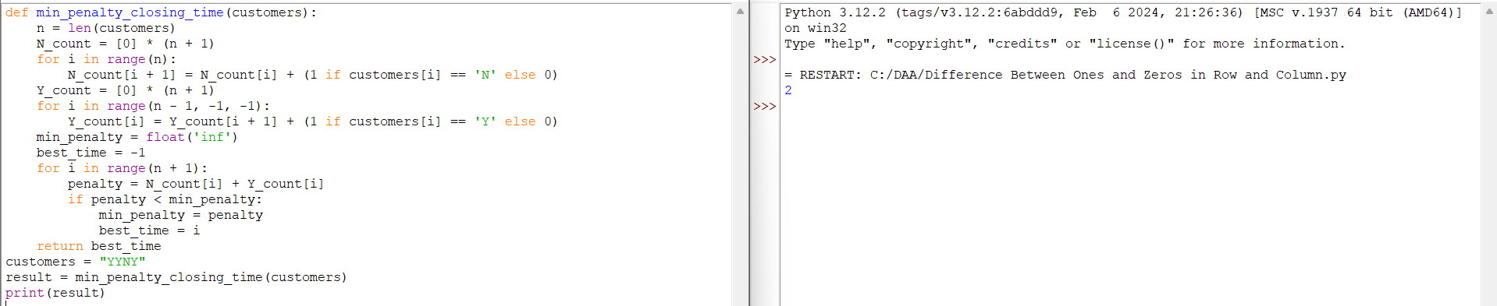

6.Count Palindromic Sequence

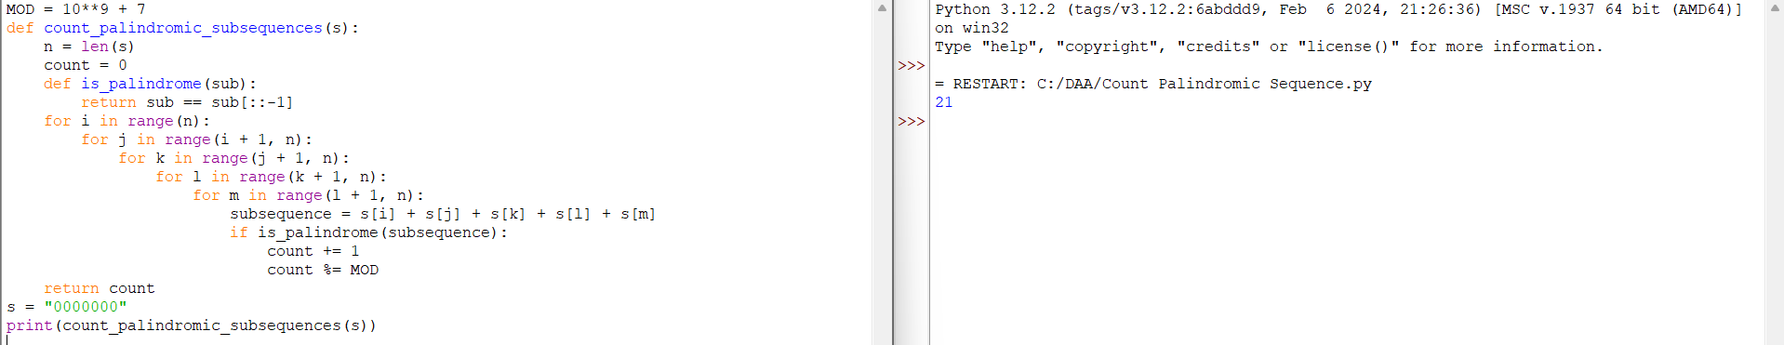

7.Find the Pivot Element

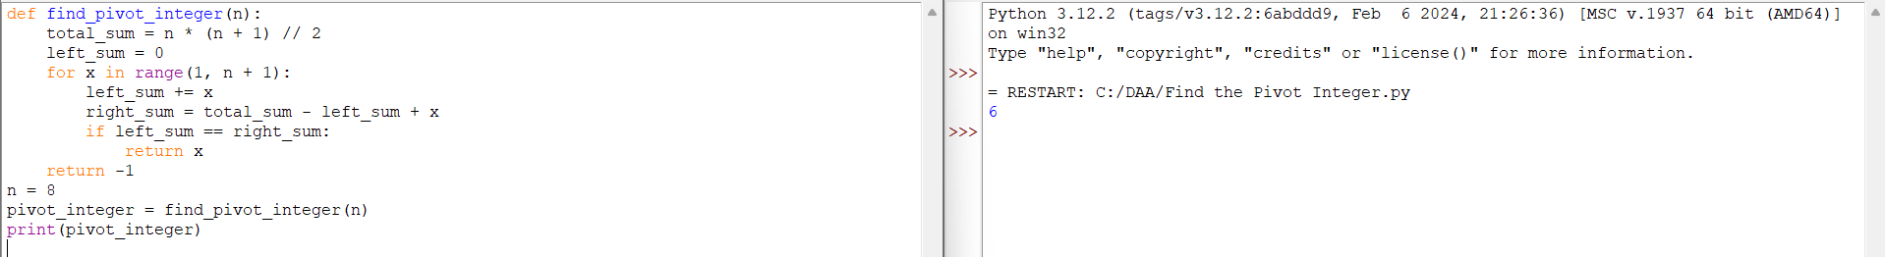

8.Append Characters to string to make Sequence

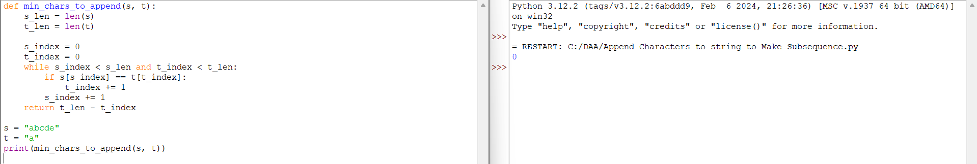

9.Remove Nodes from Linked List

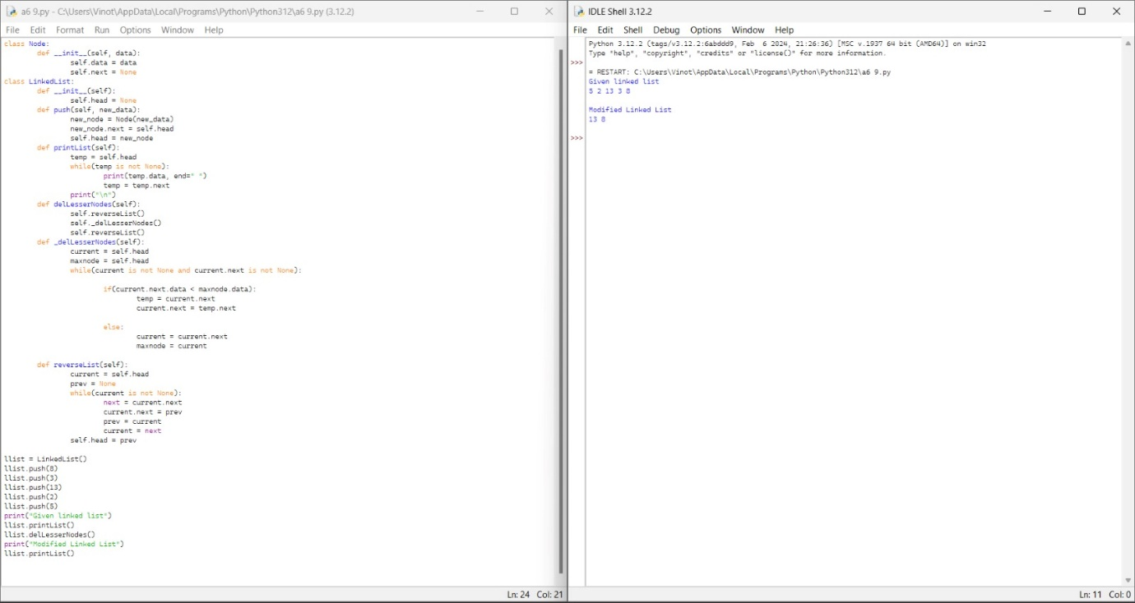

10.Count Subarrays with Median K

